FOSTON & THORNTON-LE-CLAY PARISH COUNCIL

MINUTES OF A PARISH COUNCIL MEETING HELD IN THE VILLAGE HALL
ON WEDNESDAY 05 OCTOBER 2022 AT 7.00PM

Councillors Present: Simon Burton Evelyn Conlon David Johnson Bryan Pillow Christine Walker
In Attendance: Fiona Hill - Parish Clerk
Public Present: 0

23/50a To receive apologies for absence given in advance of the meeting: Parish Councillors Calum Balding and Paul Readey
23/50b To consider the approval of reasons given for absence: Resolved/Approved (Unanimous)

23/51 To record declarations of interest in items on the agenda: None

23/52 To confirm the minutes of the meetings held on Wednesday 07 September 2022:
Resolved – Approved (Unanimous)

23/53 To discuss new planning applications received: 22/00870/GPAGB - Change of use and alteration of agricultural buildings to a four bedroom dwelling and detached domestic outbuilding (Use Class C3) @ Station Farm, Rice Lane
RDC had advised the Parish Clerk that this is prior approval to convert an existing agricultural building into a dwelling and Parish Councils are not consulted.

23/54 Public Session: None

23/55 To discuss matters arising from previous minutes: None

23/56 Councillors to discuss long-standing matters: - White Swan Inn – NTR
- Highways issues – NTR
- BT Phone Box (Thornton-le-Clay) – Resolved – The Parish Council would draft a statement detailing the options, to seek opinions on what parishioners would like to see happen with the phone box.
- Rights of Way – Alicia Atkinson, Countryside Access Service Technical Officer, North Yorkshire County Council had emailed – “The bridge was included in the most recent bridge replacement programme and has now been replaced, see attached photo. Therefore the case has now been closed”.

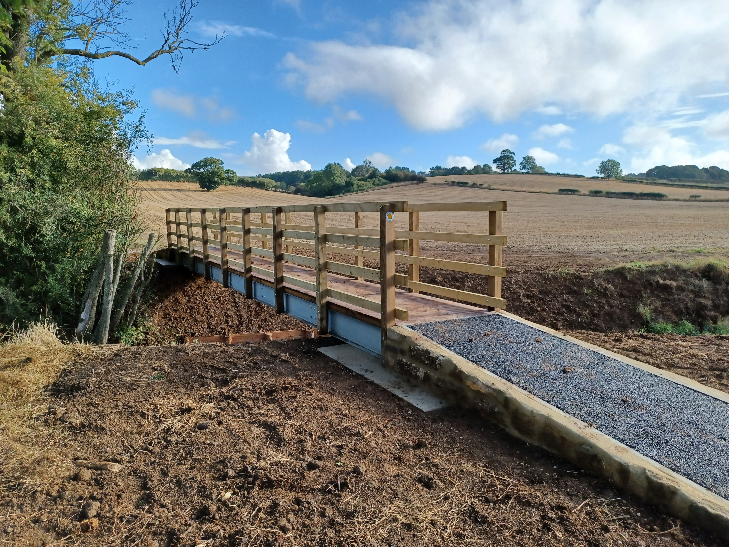

- Questionnaire/Newsletter – Cllrs Johnson and Walker would make a start with work recording results and agreeing actions.

23/57 To discuss matters raised by Parish Clerk/Responsible Financial Officer:
- Bookkeeping records to date - Cllrs had received copies of the spreadsheet via email, including a bank reconciliation totalling £9536.91, along with an income & expenditure.
- Financial Management -
Banking – The NS&I bank mandate is in need of updating.
Internal Control Check(s) – Cllrs conducted a number of checks and everything was found to be in order.
Internal audit report for year ended 31 March 2022 – Completed, to be removed.
Property Checks –Cllr Burton had conducted inspections and repairs and the Parish Council thanked him for this work.
Yorkshire Local Councils Association – NTR
- Payment Approval - Resolved/Approved (Unanimous) - None

23/58 To report any new correspondence received by the council: None

23/59 To receive matters raised by members: None

23/60 To confirm the dates of the future meeting(s) on Wednesdays at 7.00 p.m. in the Village Hall, Thornton-le-Clay:
2022 Dates - 02Nov, 07Dec 2023 Dates - 04Jan, 01Feb, 01Mar, 05Apr, 03May, 07Jun, 05Jul, 02Aug, 06Sep, 04Oct, 01Nov, 06Dec

